Adding Alignments in Blackboard-EAC
UMBC FDC Jennifer M. Harrison jharrison@umbc.edu updated 3-5-18

What Does EAC Add to Blackboard?
EAC Visual Data is a Blackboard building block that can help streamline some elements of your learning assessment process.
- EAC enhances Blackboard’s Goals and Assessments tab—it allows you to connect learning results to outcomes, so you can view how well students achieved course, program, or institutional-level learning outcomes in tests and assignments you have graded using a rubric.
- EAC makes it possible to aggregate rubric and test data across classes and assignments.

Follow these steps to align rubrics (or tests) to outcomes:
- Open your Bb course and go to Course Tools, Rubrics. Find your rubric and click the action arrow. To align the rubric as a whole, choose Add Alignments (see blue braces) from the menu.
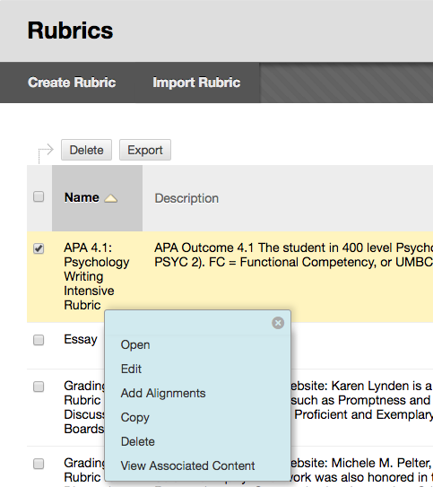
- The Alignments box opens. Click on Add Alignments (see white braces):
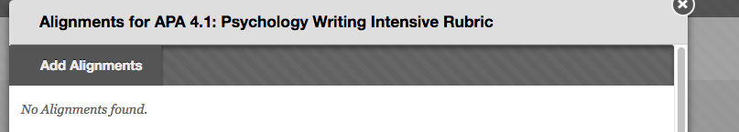
- The Discover Goals box opens. To begin with UMBC Functional Competencies, limit the goals list by clicking on Institutional-Level Outcomes. Choose the outcomes that you want to align to the entire rubric.
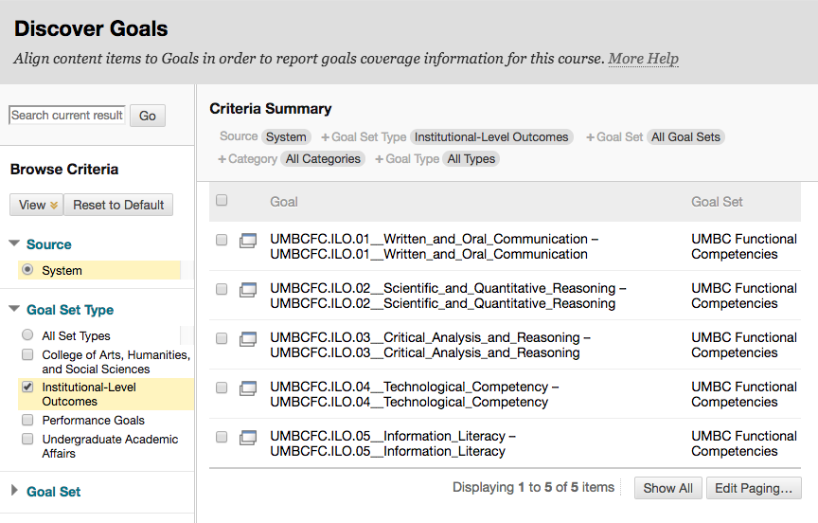
- To align outcomes to rubric row criteria, find your rubric in the Rubric menu, click the action arrow, choose Edit.
- Each rubric criterion has its own action arrow—click the arrow and choose Add Alignments:
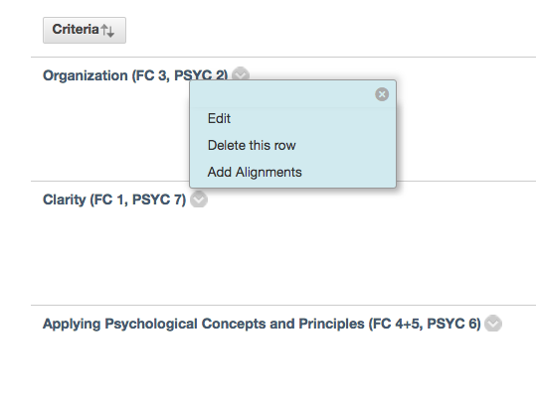
- Click Add Alignments in the box that opens (see 2 above). Then use the Discover Goals box to select your outcomes. Use Goal Set Type or Goal Set to narrow your choices. For example, in the screenshot below, CAHSS is selected, so only CAHSS outcomes appear:
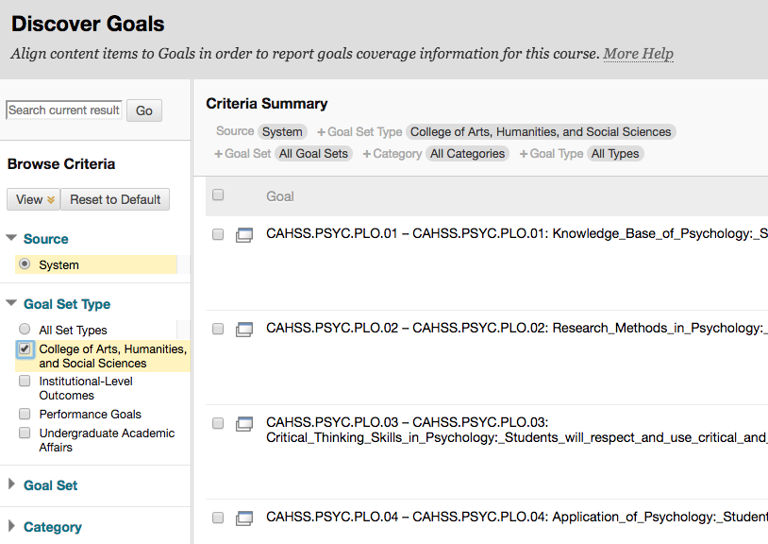
- Click on the box(es) of the relevant outcome(s). Then click submit.
- You can view what you’ve added in the Add Alignments box—here FC 1 and Psychology BA/BS Outcome 7.:
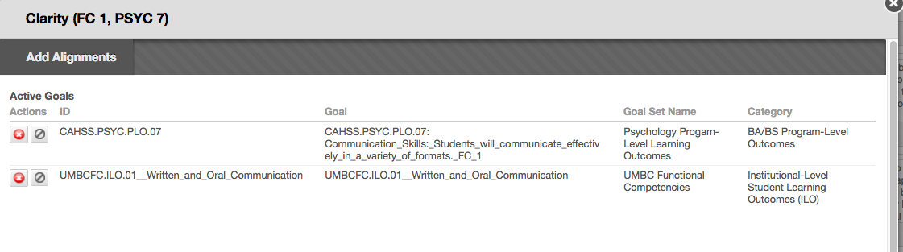
- Repeat these steps for each row.
- To view the results, go to Course Tools, EAC.
- In EAC, adjust the date at the top and click on Rubrics. (If you are the Instructor, you won’t need to change your role. But if you are aggregating rubrics from multiple classes, then you will need an Administrator role.)
- Find your rubric. If you just want results from one rubric, just click on the name. If you are aggregating multiple rubrics, click on the number. Below 12 uses of the APA rubric in Psychology appear. Just click on the number of any rubrics you want to exclude. When you have the selection you want, click the rubric name, and your report will start to process.
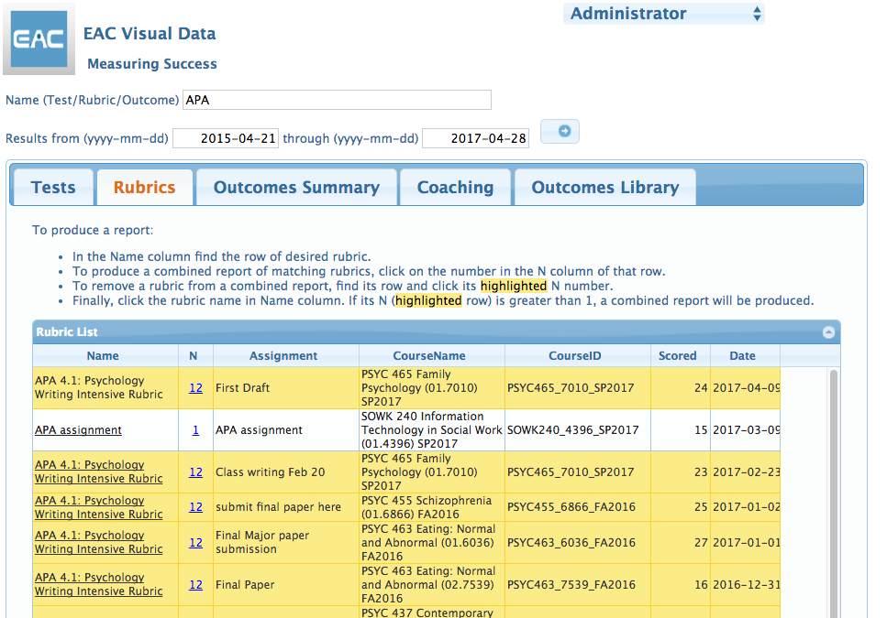
- EAC presents the data in the next screen—you can download it all into Excel for additional analysis and processing.
- The third tab is the Outcomes Manager. Here you can align outcomes in a slightly different format from Bb. You can click multiple outcomes and link them fairly quickly.
- The second tab shows you the results in a table:
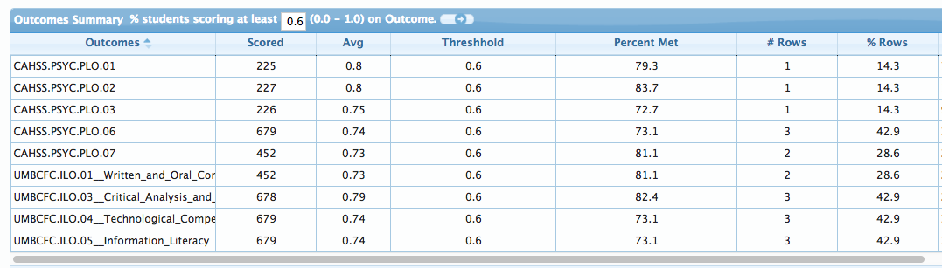And in a bar chart.
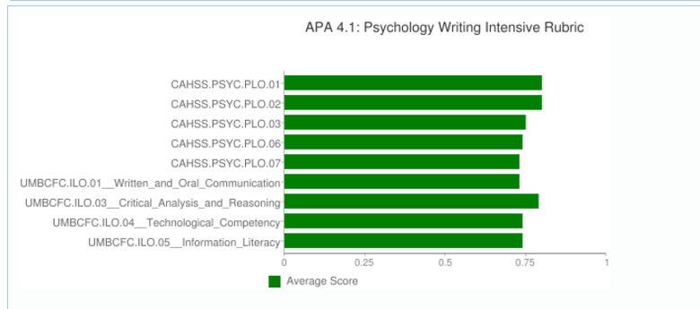
- The first tab is the Row Analysis tab, which summarizes the statistics and presents the results in a number of ways. The Details box show the percentages of students who reached each level of achievement for each rubric row.
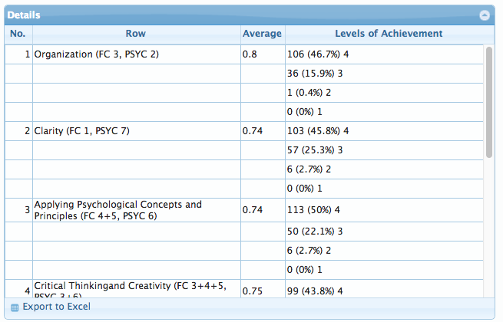

Follow these steps to align tests or quizzes to outcomes:
- Open your Bb course and go to Test, Surveys, and Pools under Course Tools. Select Tests, then find the test you want to align. Click on the action arrow, then choose Edit from the menu.
- When the Test Canvas is open, you can align the entire test by clicking on the action arrow next to the name of the test. Choose Add Alignments from the menu, and the Discover Goals menu will open.
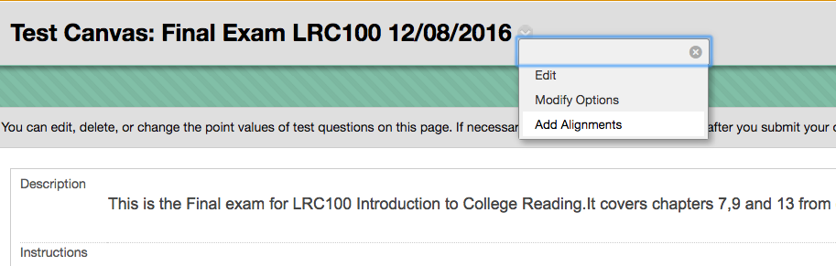
- To align each question to course, program, and institutional learning outcomes, click on the action arrow next to each question name and choose Add Alignments.
- The Discover Goals menu shows all the UMBC outcomes entered into Bb so far. Use Browse Criteria to find the set(s) you want to use.
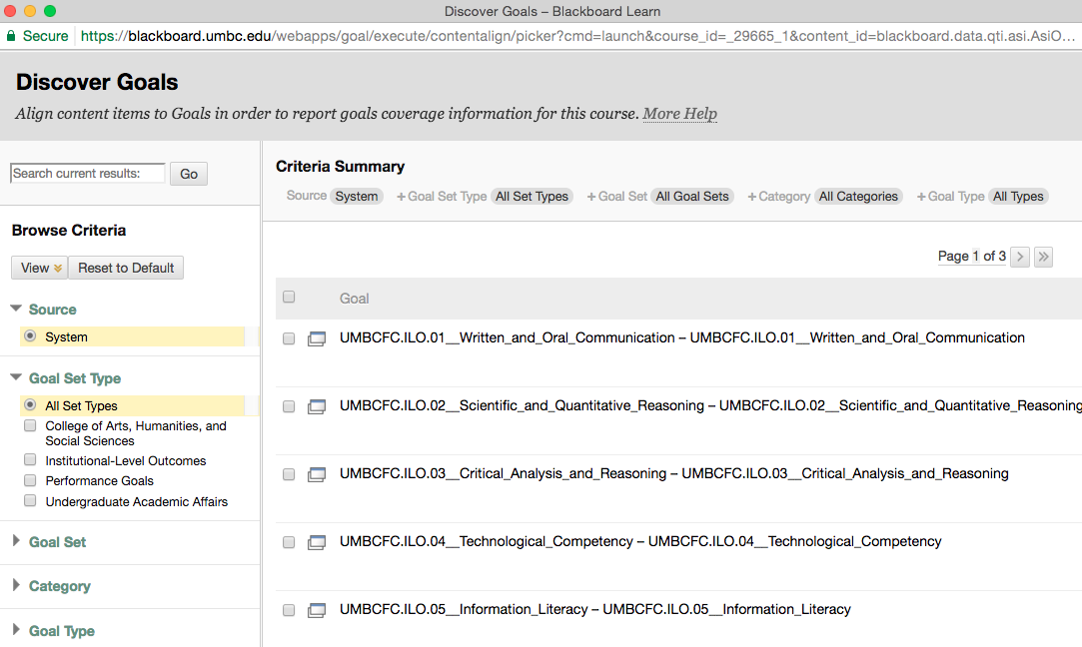
- Consider starting with the UMBC Functional Competencies, since they appear first. Click the box next to the Goal, and a green badge will appear saying Item Selected. You can see the Selected Goals at the bottom of the box.
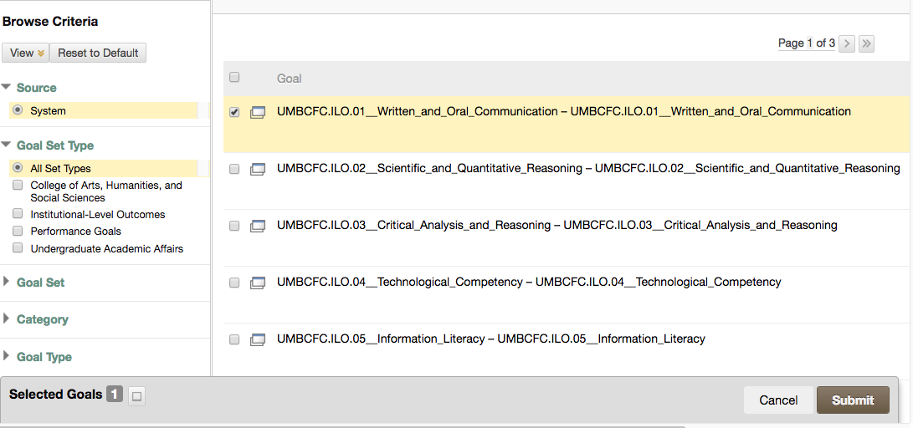
- Use the Goal Set Type or Goal Set sorting options in Browse Criteria (on the left) to find the other goals. For example, you can choose Undergraduate Academic Affairs to see the goal sets (that have been added) in that division. In the screen shot below, you could choose OUE or LRC program goals. If your course-level outcomes do not appear, email me, and we’ll work together to add them.
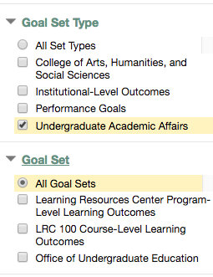
- Once you’ve selected all the outcomes you need, click the Submit button.
- The outcomes you have selected will appear under the test question in the Test Canvas.
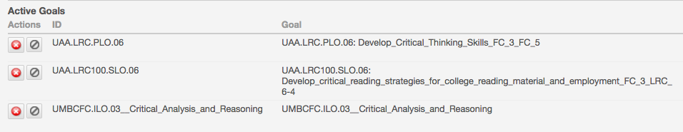
- You can also create these alignments in EAC’s Outcomes Manager. Choose EAC Visual Data from Course Tools in Blackboard and find your test. Click on it to view EAC’s analysis tabs.
- The third tab, Outcomes Manager allows you to add alignments. Click on the box next to the question in the right-hand box (red braces), then choose the outcome from the list on the left and click the arrow (blue braces).
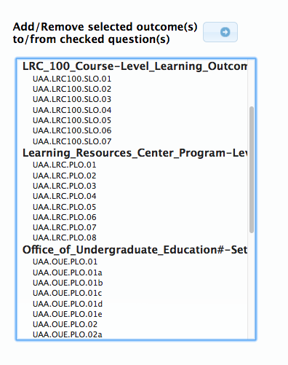
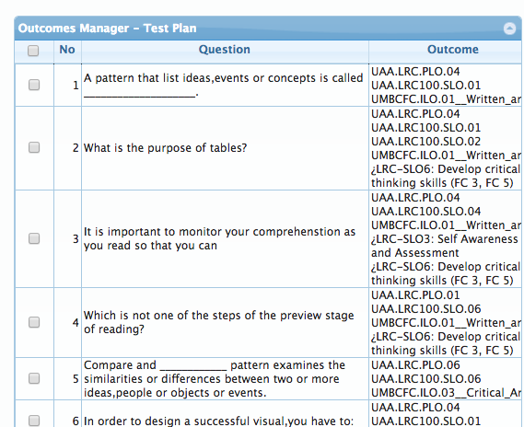

- Click on the Learning Outcomes tab, where EAC summarizes the results for you like this:
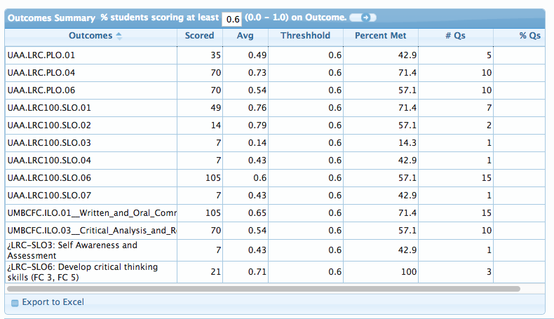Here you can see how many times each outcome was scored, the average score for each outcome, the Threshold (here it is set to .6 or 60%, but you can adjust it), how many students met the Threshold, and the number of questions where this outcome was demonstrated. (Note that EAC counts each question or rubric criterion as one point.)
- EAC also provides a bar chart with results for each outcome. (Note that EAC counts each question or rubric criterion as one point.)
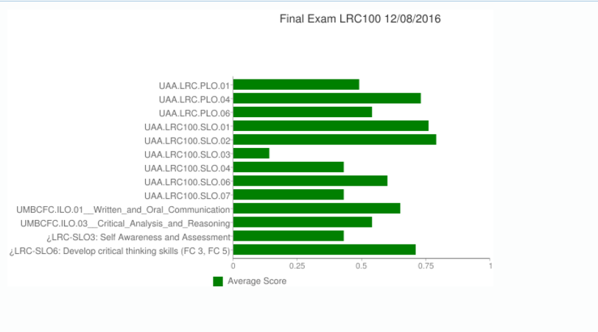
- The first tab in EAC offer an Item Analysis, where you can analyze your test questions, view aggregated results by question, and view individual student results.

~written 10/10/16; updated 4/28/17 and 2/14/18

